Unit 1.2 – Using Java Classes

Reference : Java Class Essentials

What is Object Oriented Programming?
In classic, procedural programming you try to make the real world problem you're attempting to solve fit a few, pre-determined data types: integers, floats, Strings, and arrays perhaps. In object oriented programming you create a model for a real world system. Classes are programmer-defined types that model the parts of the system.
A class is a programmer defined type that serves as a blueprint for instances of the class. You can still have ints, floats, Strings, and arrays; but you can also have cars, motorcycles, people, buildings, clouds, dogs, angles, students, courses, bank accounts, and any other type that's important to your problem.
Classes specify the data and behavior possessed both by themselves and by the objects built from them. A class has two parts: the fields and the methods. Fields describe what the class is. Methods describe what the class does.
Using the blueprint provided by a class, you can create any number of objects, each of which is called an instance of the class. Different objects of the same class have the same fields and methods, but the values of the fields will in general differ. For example, all humans have eye color but the color of each human's eyes can be different from others.
On the other hand, objects have the same methods as all other objects in the class except in so far as the methods depend on the value of the fields and arguments to the method.
Another common analogy is that a class is to an object as a cookie cutter is to a cookie. One cookie cutter can make many cookies. There may be only one class, but there can be many objects in that class. Each object is an instance of one class.
The main advantage of Object Oriented Programming is that it allows us to organize our data the way humans see it rather than trying to force ourselves to think the way the computer sees it.

Making and Using Objects from predefined Java Classes
Java has a wide variety of classes. A few of the classes are essential to know and the others you learn if and when you need them. String is perhaps the most important class in Java but because of how central it is it breaks some of the rules to make it easier to use so we'll start by looking at a more standard class, Point.
e.g.
Point start = new Point(50, 100);

Point is the class. start is still called a variable, but it is also referred to as an instance of the class Point or simply as a Point object. An object is like a variable that is a primitive type because it holds data but an object also has methods that it can use.

Objects and classes have Fields and Methods
Fields - The data that describes specific characteristics of the object, specifically the data that separates it from other objects of that class. For example, if we had a class called Human and suppose joe is a Human and amy is a Human. It would make sense to have a field called "eyes" where we could store each Human's eye colour, but it would not make sense to have a field that kept track of number of eyes. Even though having two eyes is data about Human it's not useful because it doesn't separate one human from another typically. With many classes you can not directly access the fields, when you can it uses a dot notation. e.g.
Point start = new Point(50, 100);
start.x = 25;
start.y = 70;

Methods – The functions that the object can perform. They look like:
start.move(10, 200);

In Python we had methods that our variables could perform and we also had general functions and in Turing we had general functions and procedures. With general functions we pass our data into our functions like:
capitalize("dog")
with objects and their methods we want to organize it like:
"dog".capitalize()

This seems like it is an arbitrary distinction. Who cares which order I do things in if the end result is the same. The key differences are that the second way helps us organize our functions into logical divisions nicely so we only have to focus on the class we are using and it helps reduce errors because we don't accidentally pass the wrong data to the wrong function. Even in the simple example above suppose I also wanted a function that took in the name of a country and it told me the capital. In the procedural way I would need two different names for my two functions like:
capitalizeString
capitalizeCountry
or I could use simpler names like :
capitalize
capital
But this is an accident waiting to happen, I will end up passing my data to the wrong function and start thinking that the capital of Canada is CANADA.

In the method notation I have String objects and I have Country objects, each one has it's own method, so using it would look something like:
name.capitalize()
home.capitalize()
Java's class structure is massive. You can not expect to memorize all of the commands that you need. You should try to memorize some of the more common ones but you need to keep the reference sheets I give you in front of you as you program and you need to comfortable accessing the API (application programming interface) yourself. In JCreator Ctrl-F1 should bring up the API. The API is basically just a description of all the classes in Java. Find the API reference for Point, it should look like:
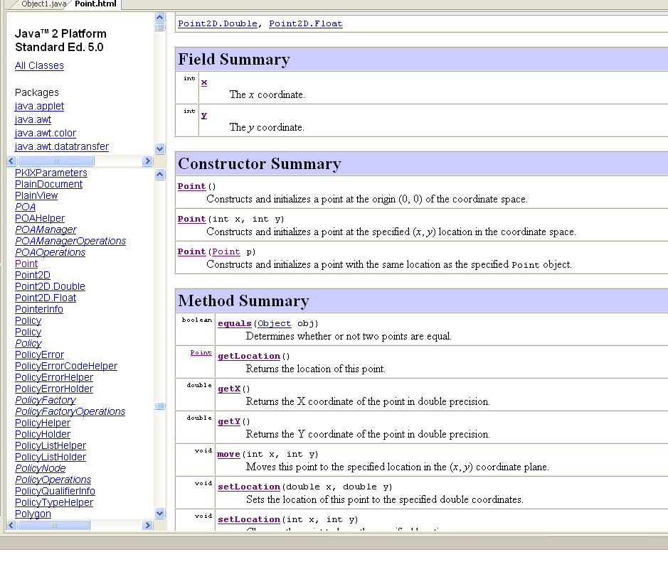class methods vs. object methods

If a method is declared as static that means it belongs to the class, otherwise the method is performed by individual objects. Here are some basic examples of object methods.
// ObjectMethods.java
// A look at calling object methods
import java.awt.*;
public class ObjectMethods{
public static void main(String [] args){
Point start = new Point(50, 100);

start.translate(10,10);
System.out.println(start);
start.move(50,10);
System.out.println(start);
}
}

When calling a class method you use the class name to the left of the dot. There is no need to create an object first. All of the methods in Math are static so you will never need to create a Math object.
// ClassMethods.java
// A look at calling class methods
import java.awt.*;

public class ClassMethods{
public static void main(String [] args)
{
double radius = 12.5;
double area = Math.PI * Math.pow(radius,2);
System.out.println(area);
}
}

You will notice that PI is actually a static field in Math.

Internal representation of objects.

With primitive types what the variable holds is simply the data. With objects what the variable holds is a reference to the object (ultimately, this "reference" is an address in memory)
x |  | name |  | middle
12
int x = 12;
String name = "McKenzie";
Point middle = new Point(20, 40);
"McKenzie"
x: 20
y: 40

// ShallowCopy.java
// A look at the problems with shallow copies
import java.awt.*;
public class ShallowCopy{
public static void main(String [] args){
Point start = new Point(20, 50);
Point next = start;
next.translate(10,0);
System.out.println("Start is at: " + start);
System.out.println("Next is at: " + next);
}
}

When you run this program you will see that both points are at spot (30, 50) What happens is when I assign next = start, next now points to the same object that start does. When I change next they both change because there is, in fact, only one object.

Shallow Copy – Copying a object reference

Deep Copy – Copying the contents of the object

// ShallowEquals.java
// A look at deep and shallow comparisons
import java.awt.*;
public class ShallowEquals{
public static void main(String [] args)
{
Point start = new Point(20, 50);
Point next = new Point(20, 50);

// Shallow Equals
if(start == next){
System.out.println("They have the same reference");
}
// Deep Equals
if(start.equals(next)){
System.out.println("They have the same contents");
}
}
}

There is one thing you need to realize and remember after running this:

YOU MUST USE .equals TO COMPARE THE CONTENTS OF OBJECTS, EVEN STRINGS !!!

Strings
You will use Strings quite a bit in Java so it is important to be very familiar with how they work. String is a class, so any strings you make are objects, even string literals like "dog". So if you want to check if the contents of two strings are the same you need to use .equals.
e.g. name.equals("McKenzie")

Strings are immutable
Sounds like I'm saying that you can't change your string after you make it.

String name = "McKenzie";
name = "Mr." + name;

hmmm, this works just fine.
What happens "under the hood" is:
name
"Mr." + name
creates a new String object, then
name = "Mr." + name;
assigns this new object back to the original variable.
McKenzie

Mr. McKenzie

Why do we care?
When you understand what's going on under the hood you won't be surprised when Java acts inconsistent. When your program gives you error messages of even results you did not expect it is important to stop and try to figure out why it is doing what it is doing. Once you do this not only will you be able to fix your error but you will be less likely to make the same one in the future.
// String2.java
// A detailed look at Strings with deep and shallow comparisons
public class String2{
public static void main(String [] args){
String answer = "yes";
String original = answer;

answer = answer.toUpperCase();

System.out.println(original);
System.out.println(answer);

// Shallow Equals
if(answer == "YES"){
System.out.println("They have the same reference");
}
// Deep Equals
if(answer.equals("YES")){
System.out.println("They have the same contents");
}
}
}

When you run this you get:
yes
YES
They have the same contents

Think about what is going on in this program. I make two strings, the first I set to "yes" and the second one I set equal to the first. When I do this both variables are pointing to the same object just like what I did with the Points earlier. When I change answer I would expect both of them to change, but only answer changes. This is because of the whole "immutable" thing. Because the String can not change in place Java creates a new String then answer refers to that new one, leaving only original to point at the original. Please don't be surprised when the shallow equals (==) did not work.

Basic String Manipulation
The String class has a lot of very useful methods and I encourage you to look at the API and try to look for opportunities to use ones that you haven't used before to solve problems in the future. As a matter of fact I often look at the API myself and think "Wow this problem would be really easy if they used that method. I wonder if anyone will find it … hmmm." On the reference sheet I list the ones that I feel you absolutely must know. Here are some basic examples:
/* String3.java
* My keyboard is really sticky (maybe I shouldn't eat chocolate bars
* while I'm programming.) I constantly have the problem of keys
* repeating. This program reads in a line of text and removes
* any extra repreated letters. e.g.
* input: Jaava isss my fffavoriite langgguage
* output: Java is my favorite language
* I know this will make some words a little hard to type but
* I think double letters are dumb anyways. What's wrong with:
* lok at my fet */
import java.util.*;

public class String3{
public static void main(String [] args){
Scanner stdin = new Scanner(System.in);

String line = stdin.nextLine();
String newLine = line.substring(0,1);

// go through the original one letter at a time and build up
// a new copy. Only add the letter if it is not the same as
// the one at the end of the string
for(int i=0; i < line.length(); i++){
if(line.charAt(i) != newLine.charAt(newLine.length()-1)){
newLine = newLine + line.charAt(i);
}
}
System.out.println(newLine);
}
}

There are not a lot of lines of code in this example, but there are a number of subtle little things that you need to look at.

String newLine = line.substring(0,1);

The String indices are the same as they are in Python, numbers start at zero and the end position is not included. So in the line above the substring is only the first character. substring can be used in two ways:

substring(int start, int finish)
substring(int start)

If the end is not specified it will go to the end of the string.

Characters and Strings are not the same
'A' - this is a character. It is just the numeric value 65, it's ASCII value.
"A" - this is a String. Java will set up a reference to a spot in memory where the A can live

If I used:
String newLine = line.charAt(0);

I would get an error. I could have used:
String newLine = "" + line.charAt(0);

In Java whenever you try to add any non-string to a String Java will convert the non-string into a String. This is actually a very common way to convert int to String. You will notice that this is exactly what is happening here:
newLine = newLine + line.charAt(i);

Hopefully by looking at the code you have figured out:
- length() returns the number of characters in a string
- charAt(int i) returns the character at the given position in the String
- line.charAt(i) != newLine.charAt(newLine.length()-1) is a shallow equals, but that's OK because they are just numbers.

This next example is a little challenging. Read the first block of comments and try to solve the problem on your own. If you get stuck look at the second block of comments. If you are still stuck look at my program, understand what is going on then go back and fix yours. Try to avoid typing my code in word for word, it is very hard to avoid though. Once you see a problem solved a certain way it is hard to see it any other way.
/* String4.java
* I have a tendency to repeat myself when I type to repeat myself when
* I type. Sometimes I actually want to repeat myself for emphasis but
* usually it's just because I'm getting old. I want this program to tell
* me what I repeated. I only care about repeats that are longer than 5
* letters otherwise double letters will even look like a repeat.
*
*
*
*
*
*
*
*
* My approach to solving the problem is to start by saying
* that the repeat could start at almost any point in the string
* so I loop through each position. From here the repeat can
* be of any size from 5 to half of the rest of the string.
* half because it needs space to repeat. I make two substrings,
* one after the other and check them.
*/

import java.util.*;

public class String4{
public static void main(String [] args){
Scanner stdin = new Scanner(System.in);

String line = stdin.nextLine();

for(int i=0; i <= line.length()-10; i++){
for(int len = 5; len <= (line.length()-i)/2; len++){
String sub1 = line.substring(i,i+len);
String sub2 = line.substring(i+len,i+len*2);
if(sub1.equals(sub2)){
System.out.println("Dude, you repeated " + sub1);
}
}
}
}
}

There is not much new in the way of Java syntax, but the logic is more advanced. You will notice that I add two variables, sub1 and sub2, that I don't actually need. Even though I can make the program without them they are very very important. Without them my comparison would be a big tangled, unreadable mess.

Exercises
1. Mrs Nantias is very concerned about the use of swear words on the computer. She feels the situation has gotten out of control and she wants me to handle it in an automated fashion. Because I don't like seeing swear words even in programs I think it's best if we simply get rid of all four letter words. Create a program that reads in one line from the user and repeats the line back with all four-letter words removed. Save as StringEx1.java

2. Although I never swear, I feel bad for those who will now have all of their swear words censored. So many students will be unable to fully express their feelings. To help them out we should encrypt their messages. We will use a simple system where cut each line in half and build a new line by interleaving the letter from each half.
e.g.
Eat a
t Joes
Eat at Joes
Eta tJ oaes

If you have an odd number of letters just tack the last one on the end. Save as StringEx2.java

3. Integer.parseInt() takes a string and returns an integer if the string is a valid integer. For Example:
Integer.parseInt("123") returns 123
Integer.parseInt("123x") crashes
Create a program that reads a single line from the user, strips out all non-numbers, converts it to an integer then prints it. My stripping out all non-numbers I mean:
"4 score and 7 years ago" → "47" Save as StringEx3.java

Arrays
Arrays are also very commonly used objects, and they also have some special syntax to access them. Arrays in Java are very plain, they have one field that we can access, it's called length, and array objects have NO COOL ARRAY METHODS. No methods at all as a matter of fact.
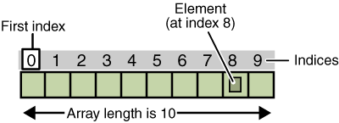
An array of ten elements
// Array1.java
// Shows how to declare, initialize and access an array
class Array1 {
public static void main(String[] args) {
int[] anArray; // declares an array of integers

anArray = new int[4]; // allocates memory for 10 integers
// or initialize the whole array

anArray[0] = 100; // initialize first element
anArray[1] = 200; // initialize second element
anArray[2] = 300; // etc.
anArray[3] = 400;

System.out.println("Element at index 0: " + anArray[0]);
System.out.println("Element at index 1: " + anArray[1]);
System.out.println("Element at index 2: " + anArray[2]);
System.out.println("Element at index 3: " + anArray[3]);
}
}

// Array2.java
// Shows how to declare, initialize and access an array
class Array2 {
public static void main(String[] args) {
int[] anArray = {12,240,3,400}; // declares and initializes array

for(int i=0; i < anArray.length; i++){
System.out.printf("Element at index %d: %3d\n", i, anArray[i]);
}
}
}

- There is no slicing of arrays as in Python.
- Arrays cannot shrink or grow.
- {12,240,3,400} is not an array literal the way that [12,240,3,400] is a list literal in Python. anArray = {12,240,3,400}; will generate an error. It is a special notation only used when you are declaring the array.
- You cannot automatically print the whole array.

// Array3.java
// Shows the use of Java's for-each loop as well as the need to initialize
// each object in an array
import java.awt.*;

class Array3 {
public static void main(String[] args) {
Point[] trail = new Point[10];

// At this spot I have 10 Points but each one has a value of null
// if I try to use them before I initialize them I will get
// a NullPointerException. Uncomment this line to see it
// trail[0].move(67,8);
for(int i=0; i< trail.length; i++){
trail[i] = new Point(i*10, i*i);
}

// the for-each loop is fairly new to Java
for(Point p : trail){
System.out.println(p);
}
}
}

Using the Arrays class
Some of the basic functionality for arrays that you would assume would be methods of the array are actually static methods of the Arrays class. Here are two important ones:
// Array4.java
// Demonstrates the use of the Arrays to add some important functionality
// to our arrays
import java.util.*; // don't forget your import

class Array4 {
public static void main(String[] args){
String []players = {"Bob", "Ann", "Sue", "Dan"};

Arrays.sort(players);
System.out.println(Arrays.toString(players));
}
}

Exercises
1. Create a program that takes the users 8 marks from last year, displays them in order and tells them how much above or below their average the mark is.
Save as ArrayEx1.java

2. Historians have just discovered that the universe started one day earlier than they originally thought, so all of our dates are actually off by one. Create a program to help with this transition. Your program will read in a line from the user and output that line with any days of the week references fixed. Every day reference should advance forward one day. e.g. Save as ArrayEx2.java
in: "We watched Friday night lights last Wednesday, it was pretty good."
out: "We watched Saturday night lights last Thursday, it was pretty good."

3. One way to get random numbers in Java is to make a Random object then ask it for random numbers. It looks like:
Random rand = new Random(); // only need to make one Random object

int die = rand.nextInt(6)+1; // nextInt(6) will return 0-5, so I add
// one to make it act like a die
double mark = rand.nextDouble()*50+50;
// nextDouble returns a double in the range 0.0 to 1.0. When I'm making up // random marks I want the range 50-100.

I have a perfectly square 30m x 30m backyard. My wife bought 10 trees and I suggested that we plant them in totally random places so that it looks more natural. My wife is concerned that if we plant any two within 3m of each other from center to center then they will have a hard time growing. I assured her that we could ensure that would not happen. Create a program that makes an array of 10 Points, assigns them random positions in my backyard. You must keep re-doing the process until no two trees are within 3 meters of each other. Save as ArrayEx3.java

